SIT723 Research:

Underwater Object Detection and Motion tracing.

**1.Preparation:**

a) Unzip the WPFAppMovie.zip given by Guangyan.

b) Open WPFAppMovie.sln in the unzipped directory.

c) Open MainWindow.xaml.cs (code file)

Set file path at Line 69 in the code to your movies video location.

d) Check background

Note: This methods results are demonstrated with 3 videos downloaded from, http://www.fishbase.us/videos/SpeciesVideos.php?speccode=85 (change ID to get more videos). Therefore, 3 videos are available in the movies folder with its background already segmented.

If you are testing on a new video other than already available, segregation background with backgroundFlag= True (at Line 55) is the first step. To get the background for your video:

* 1. Build and run the program. Wait until program finishing playing the movie and then check whether the program has generated a background image in the same directory as the movie. The background image should look like Figure 4.

模糊的照片

中度可信度描述已自动生成 Figure 4 Background image

2)Drawing Rectangle on screen to select fish and extracting data.

a) If you have the background ready, you can change background = false and then build and run the program again. When the WindowsMediaPlayer starts playing; Use mouse interaction to select a fish area. From the bottom of the fish left click the mouse button and drag on to the size if the fish and Leave the mouse left-click.

b) Video will pause and a pop-up box showing message of the extracted csv file with frame number will be saved in the movies folder. Observe the fish and select the fish again if its position changes. Do this over its multiple movements to get the data extracted.

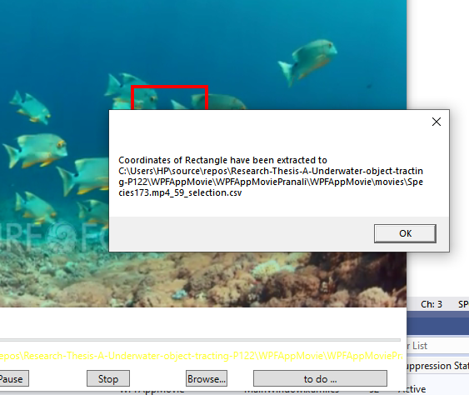

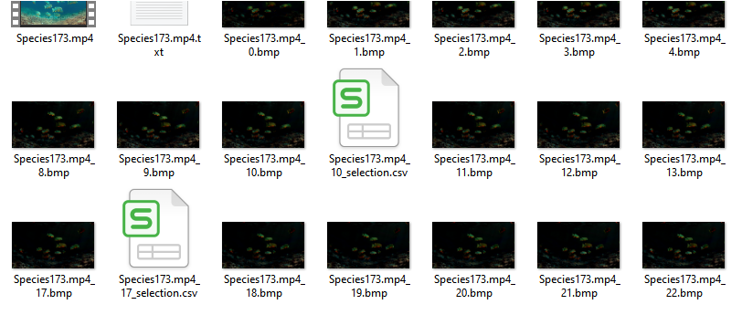

c) Once you have selected multiple movements of the fish, Close the media player and check the movies folder. The movies folder will be filled with lot of images of foreground images of the videos and csv files of data extraction in between them.

The experiment ends here, you have the data points of the fish location with you now. If you want to observe the graph, collect the coordinates (the first two columns) according to their frame numbers and draw a graph in excel. You will be able to observe the motion of the fish.